The only ones I know for sure are the BLOCK_TIMEOUT, the MASTER_ENABLE_DROPPED_OUT, and the STACK_OVERFLOW.
Warnings:
1: VAC_ABORT_POS_TOO_LONG The position for Vacuum Abort is too far out.
2: BLOCK_TIMEOUT This is really a fatal error
3: FILL_TEST_ABORT I don't know
4: MASTER_ENABLE_DROPPED_OUT master enable input went from 5 volts to 0 volts
5: VAC_ABORT_ZSPEED I'm guessing this means the rod stopped while waiting for the vacuum to turn on.
Fatal Errors
1: STACK_OVERFLOW The board ran out of stack memory (used for subroutine calls). This has never happened that I know of.
2: BLOCK_TIMEOUT Fatal error if any block takes more than 10 seconds
If you are viewing the Realtime screen of the FasTrak Board Monitor program the control step that timed out will be indicated by the "Current Step" of the control program, as shown below.
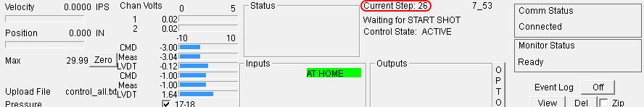
The step shown above, 26, corresponds to the first control step in the Part Setup. Current Step 27 corresponds to the second control step and etc.
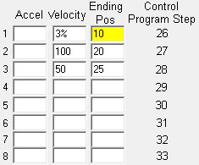

3: INVALID_BLOCK Something is wrong with the block. I don't know the rules. Invalid ending position or such I would guess.
4: BLOCK_EXECUTION_ERROR Board is unable to complete the block.
5: PROGRAM_STOPPED_BY_USER User stopped the program by entering ".H", to halt the program, in the terminal.

